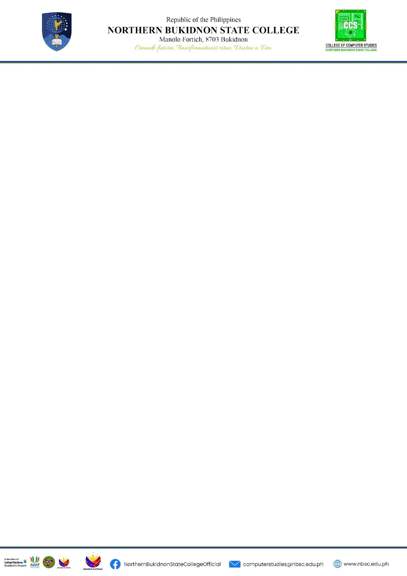

**Project Documentation**

**Title: TerraTrio**

**Members:**

Rhics T. Geonzon

GL R. Fabila

Rovic L. Maislim

**Submitted to:**

Cliff Amadeus Evangelio

1. Introduction

TerraTrio is a event-driven platform which monitors and maintains the grass across the campus of NBSC to promote a healthy, green, and sustainable environment. Through mapping techniques and icons, we showcase the grass, provide area descriptions, display corresponding images, and include the dates of grass cutting. This helps us manage overgrown areas effectively. Together, we are working to make our campus greener, one blade of grass at a time!

1. Implementation

We implement Hyper Text Markup Language (HTML) for structuring the content of our website. Cascading Style Sheets (CSS) for style and visually design the structure created by HTML. In addition of JavaScript (JS) which used for adding interactivity, functionality and dynamic behavior to web pages. And finally the JSON, which we used for structuring mapping data.

1. Conclusion

We successfully implemented this project and as a reliable and user-friendly solution for maintaining the grass within the NBSC campus. Through its innovative features and simple designs, the platform has transformed how we care for our campus grounds, ensuring they remain green and clean.

1. Documentaries

Making Website

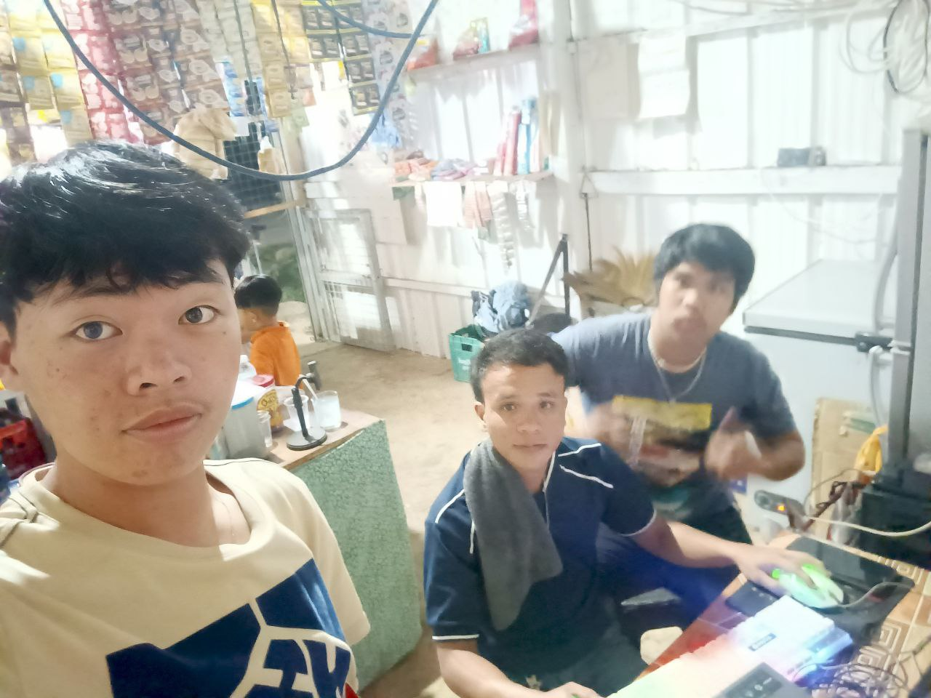



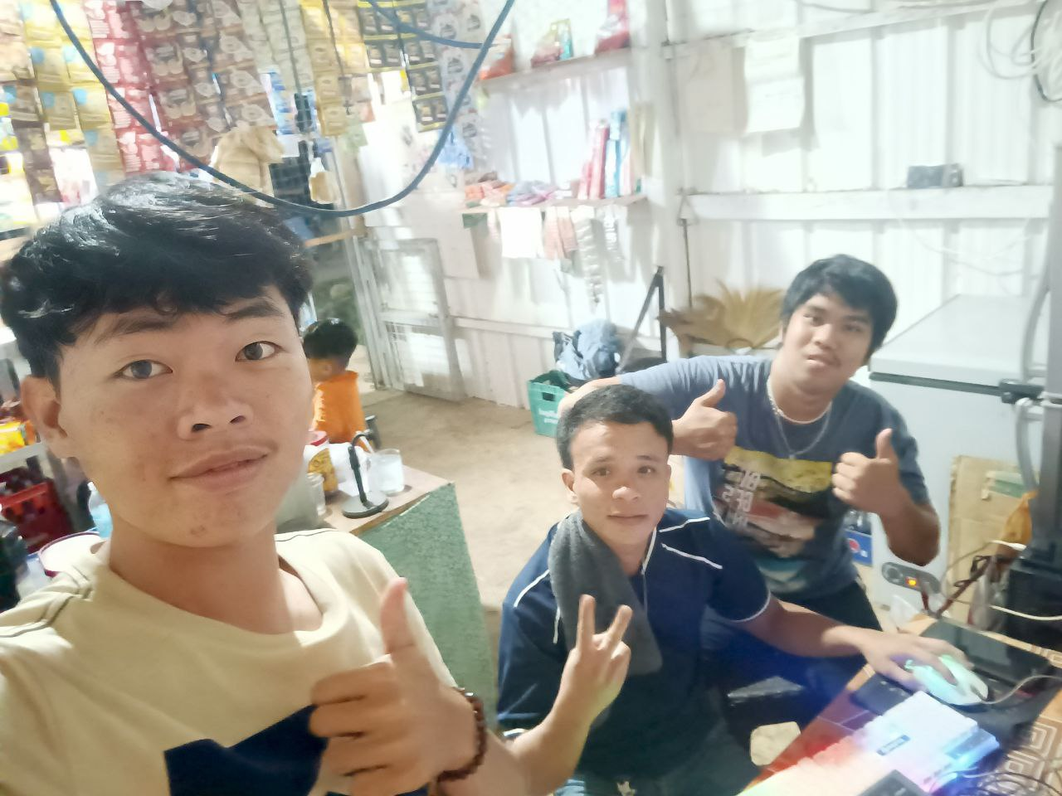

Homepage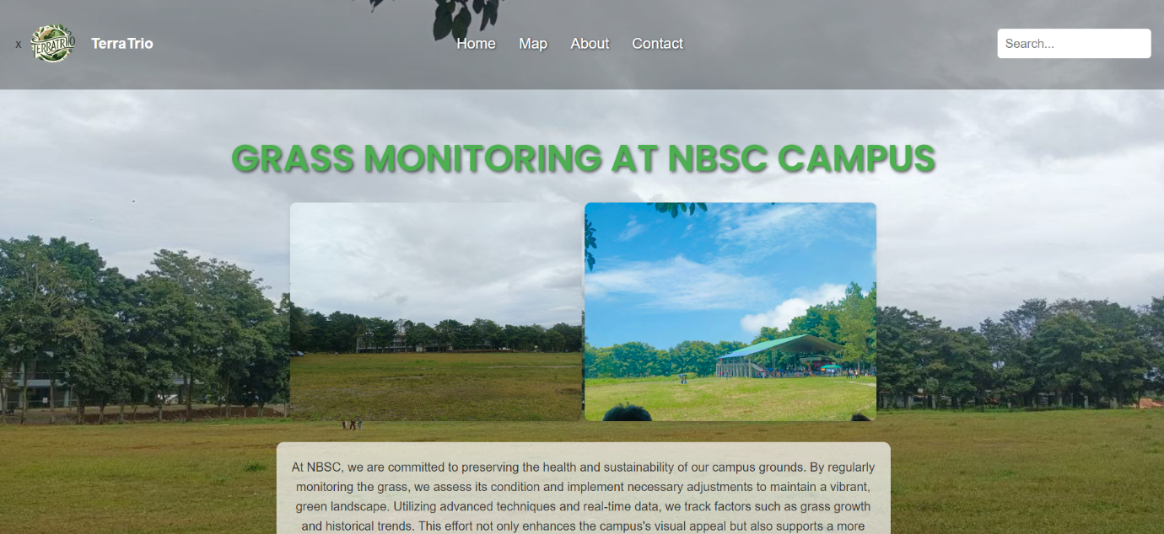

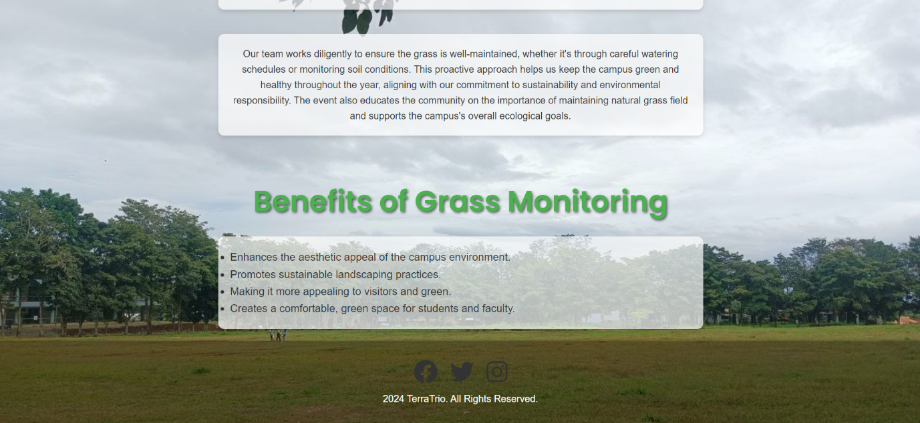

Map

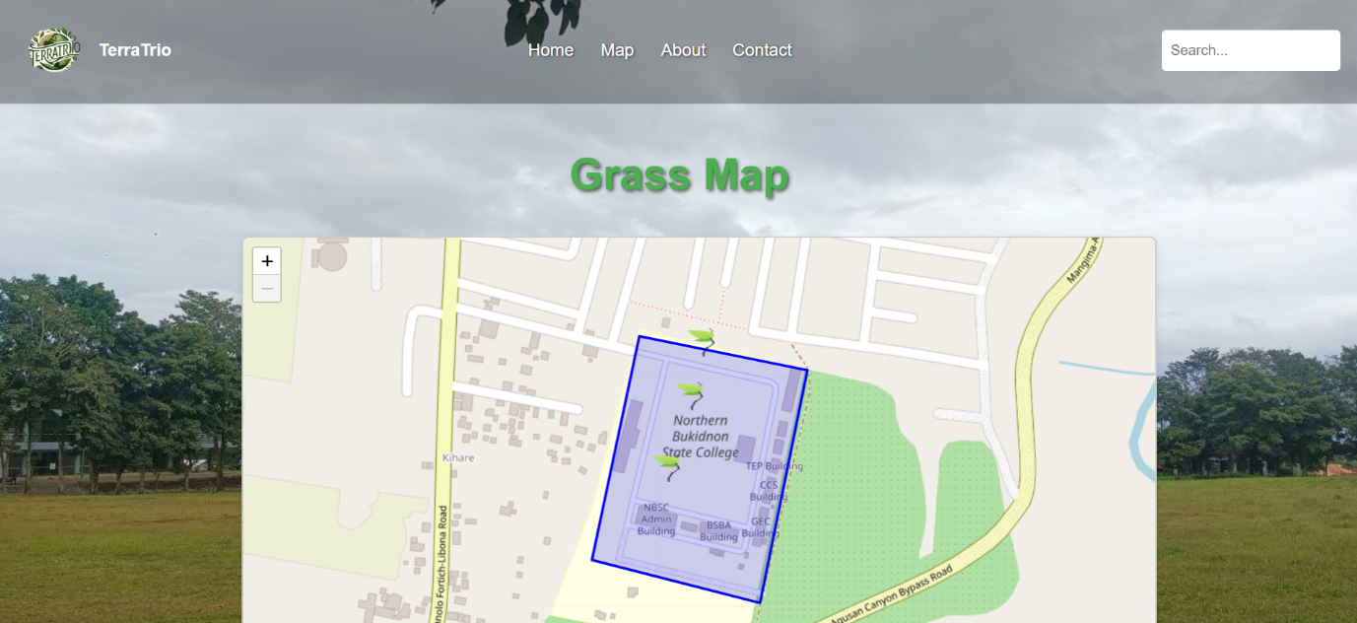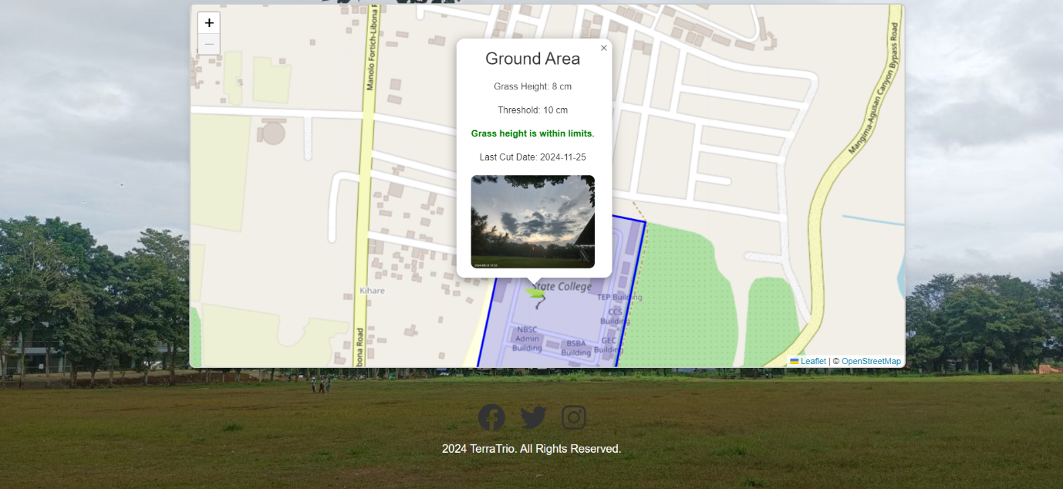

About Us

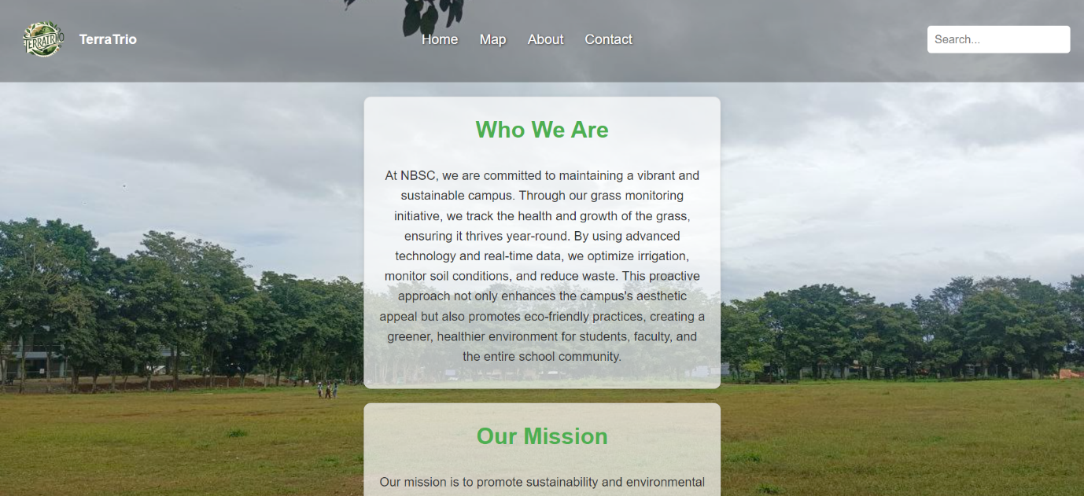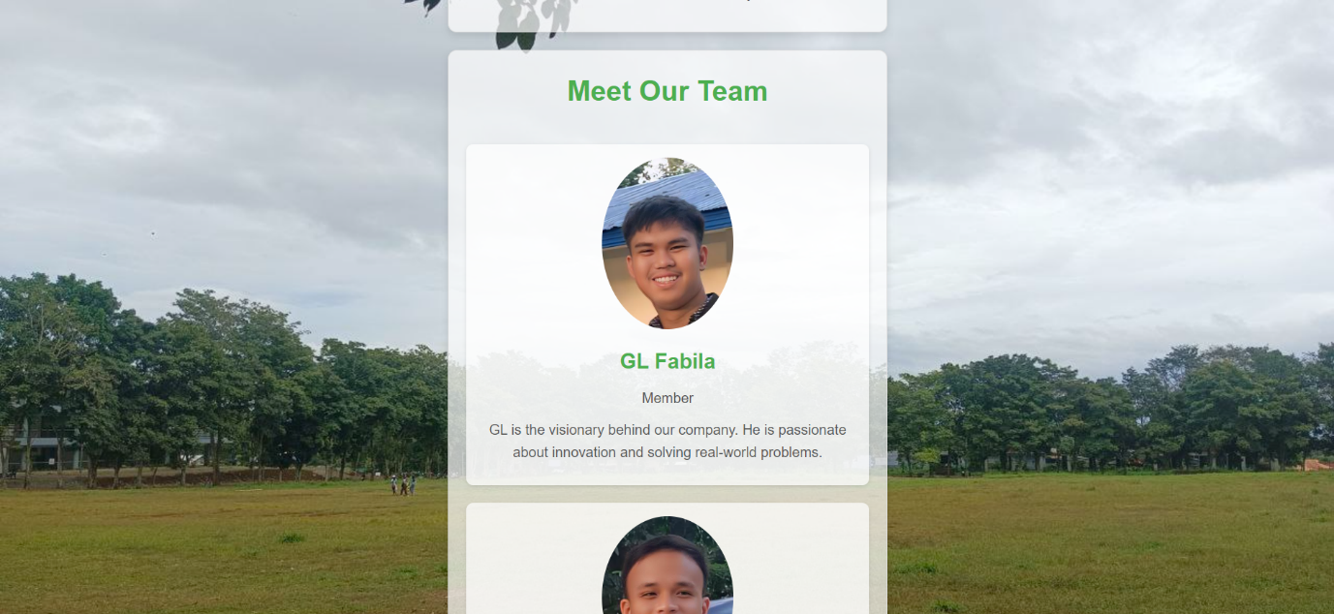

Contact